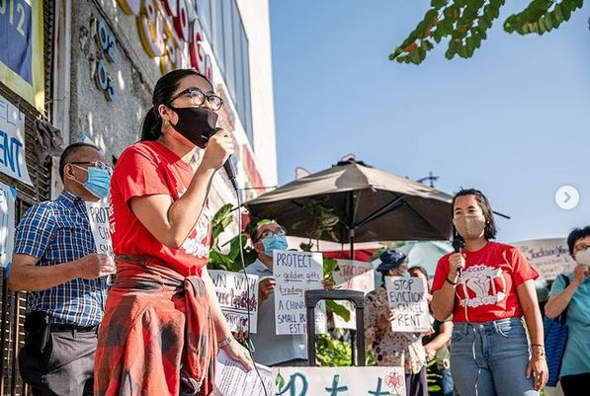

*Photo credit: Chinatown Community for Equitable Development*

**Subject: This May we honor our Asian American and Pacific Islander partners promoting mental health.**

**Headline: Our AAPI partners are shifting policies, practices, and norms to create conditions that support mental health and resilience.**

May 1st marked the beginning of [Asian Pacific American Heritage Month](https://www.pbs.org/articles/celebrate-asian-american-and-pacific-islander-heritage-month/), a time to celebrate the histories, cultures, and contributions of Asian American and Pacific Islander (AAPI) communities. May is also Mental Health Awareness month, and as Prevention Institute dives deeper into health equity and racial justice work, we see how equitable, just communities, by definition, support mental health.

This month we want to spotlight [Asian Americans Attaining Awareness](https://www.hopechc.org/about-us/programs/asian-americans-attaining-awareness/?fbclid=IwAR1xAMMVE3WgJ9waTu8MVyC-RxE4sIWGH9yc7P75fd1RX7Z0FYlZV8ucy4s) (AAAA) initiative, led by the Asian American Health Coalition. AAAA is one of ten community-based partners in [Communities of Care](https://www.preventioninstitute.org/projects/communities-care) (CoC)—a five-year initiative that supports community wellbeing in the greater Houston Metropolitan Area, with a focus on children and youth of color and their families. CoC’s goal is to transform the environments where people live, learn, work, play, and pray to support resilience, mental health, and wellbeing.

*“Asian American and Pacific Islanders is a diverse population of approximately 50 sub ethnicities that speak over 100 languages. This community that is often referred as the ‘model minority’ is perceived to be resilient. But in reality, is it?”* —Dr. Aneela Khan, Community Behavioral Health Program Manager at the Asian American Health Coalition

Asian American youth and their families struggle with misunderstandings and cultural ideas about mental health that create barriers for them to seek help. Additionally, mental health professionals and doctors have a hard time meeting the specific needs of AAPI communities due to a lack of knowledge and understanding about their culture. AAAA is addressing barriers and stigmas within Asian communities that hinder families from seeking mental health services. They’re engaging youth and families through community interventions like “chai time,” radio programs, and personal development courses to start conversations, burst myths, and ultimately consider mental health to be as important as physical.

**Learn more about Prevention Institute’s communities of practice working on transforming community conditions to support mental health:**

* [People, Parks, and Power (P3)](https://preventioninstitute.org/projects/people-parks-and-power) supports power building by community-based organizations to advocate for fair and just distribution of parks and green spaces—crucial for community health and wellbeing— in Black, Latino, and Indigenous communities across the country. [Watch highlights from their latest convening](https://www.instagram.com/reel/CsJ3IL2qlsD/) in Oakland.
* In 2016, Prevention Institute (PI) and the St. Joseph Community Partnership Fund created the [Intersections Initiative](https://www.preventioninstitute.org/intersections-initiative/about), where community organizations and collaboratives partnered with healthcare to improve community conditions like housing, education, economic and workforce development, immigration, community trauma, and civic engagement.
* [Safety Through Connection](https://www.preventioninstitute.org/projects/safety-through-connection-community-driven-culture-and-systems-change-health-equity-and) is a California program launched in 2018 with support from Blue Shield of California Foundation to sustain and grow collaborative community-driven, place-based, culture and systems change for health equity, safe relationships, and prevention of domestic violence (DV).